FEBC Russian Ministries Prayer Focus

July 2019

Thursday – 1
Please pray for FEBC-Russia’s co-worker Ludmila; she’s facing a very serious disease. Ludmila has been on FEBC-Russia’s team for more than three decades.

Friday – 2
Please pray for Eugene, an FEBC programmer who is ministering to hundreds of soldiers and their families in Eastern Ukraine. “There are so many reports coming in from military commanders – they are grateful for our ministry to soldiers. Many suffer from alcoholism, hopelessness, and there are many suicides. But God is changing hundreds of lives in this environment. Please support us in prayer.”
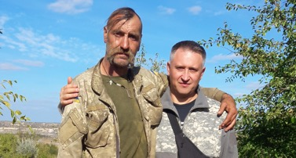

Saturday – 3
Please pray for Max, a 3-year-old boy who fell from the third floor and survived. He’s a nephew of one of our broadcasters. Please pray for this young family.

Sunday – 4
Please pray for FEBC’s ministry in the Buryat Republic, located in East Siberia. Pray that many who are in bondage to shamanism and other religions will come to see the light of Christ.
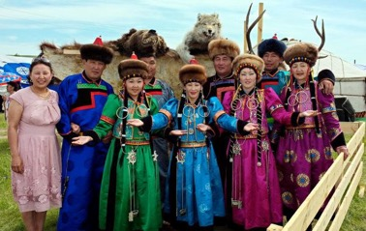

Monday – 5
Pastor Alexandr from Ukraine says, “FEBC is doing so much in East Ukraine! We are so blessed by the broadcasts that are saturating our suffering land with the grace of God. I praise God for FEBC!”

Tuesday – 6
Praise God for the people who responded to FEBC broadcasts during the first six months of 2019 – more than 1,000 responses indicated deep transformations in the hearts of our Russian and Ukrainian listeners. Please pray that God will work in their hearts as they continue to listen.

Wednesday – 7
Oleg Cherny, FEBC-Russia’s administrative director, says, “Please pray for my father, who is battling cancer.” Oleg, his father – a former military officer, and all his family came to know Christ through FEBC.

Thursday – 8
Please pray for Ukraine’s new parliament and new president. Pray that FEBC will continue to grow and inspire more Ukrainians to follow Jesus Christ in the next five years. We plan to reach 10% of Ukrainian people with the Good News in the next five years.

Friday – 9
Please pray for FEBC’s new ministry in Moldova. Political, economic, and spiritual state of affairs in Moldova is very difficult. Pray that many Moldovans will respond to the Good News heard on seven FM stations throughout the country.
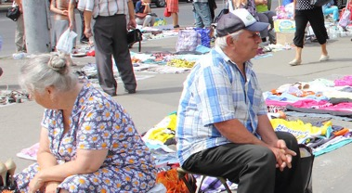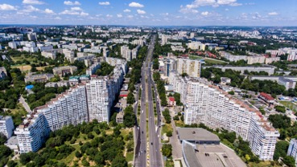

Saturday – 10
Please pray for our listener Myhailo from Ukraine. He is not a believer, but listens to our broadcasts regularly. He reached out to our broadcasters when he was suicidal because his girlfriend left him. Pray for Myhailo to accept Christ.

Sunday – 11
Please pray for FEBC-Russia’s leadership team: Alexey, Oleg, Vlad, and Victor. Please pray for wisdom as they deal with budget reductions. Pray that the ministry will not suffer, but become more effective and efficient. Pray that more people will hear the Good News in the months to come.

Monday – 12
Please pray for Dennis, our listener in Ukraine, and his newlywed wife. He listens to our programs, but considers himself an agnostic. Please pray for this young family to become Christ’s followers.

Tuesday – 13
Please pray for FEBC listeners in Siberia, where FEBC broadcasts can be heard through seven partnering stations. Pray that the Holy Spirit will touch many hearts this month.

Wednesday – 14
Please pray for FEBC-Russia’s program director, Rev. Alexey Vlasikhin. Pray for wisdom, as he is implementing our long-term strategic plan; pray, too, for the empowerment of the Holy Spirit on him and the entire team of programmers and volunteers. Also, please pray for Alexey’s and Natalia’s daughter Katya, who is facing some health challenges.
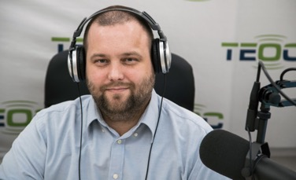

Thursday – 15
“My church members are well served by what they hear on FEBC, and many use FEBC as a tool to evangelize their friends. I pray for you all the time,” said Pastor Peter from Moscow. Please join Russian ministers in prayer for FEBC’s media ministry.

Friday – 16
Please pray for Anna, a popular Ukrainian blogger who became interested in Christianity after she had several encounters with FEBC programmers. Pray that Anna will become a follower of Jesus.

Saturday – 17
Please pray for FEBC listener Pavel, who lives in the area of Eastern Ukraine, controlled by the rebels. Also, please pray for churches that suffer under severe restrictions in that area.
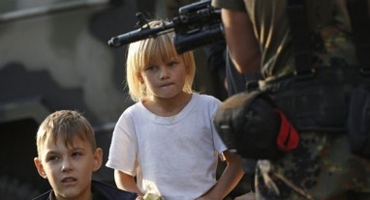

Sunday – 18
Inna from Podolsk contacted us and shared the following: “I grew up on FEBC’s programs. I am teaching children in our church today using your materials. Thank you for impacting generations of Russian people.” Praise God for FEBC’s long-term commitment to countries like Russia, Ukraine, Moldova, and Belarus.

Monday – 19
Please pray for Nadia, FEBC listener in Western Ukraine. “As we faced the death of a child in our family, we began thinking about God. We are your listeners, and now understand why you talk about God so much. Please pray for our entire family, so we understand more about Jesus.”

Tuesday – 20
Please pray for Rev. Rudi Wiens, who’s developing the ministry in Central Asia. Rudi is a veteran broadcaster and one of the most experienced FEBC leaders. Pray that God will continue to use Rudi in a special way.

Wednesday – 21
Please pray for Sergey, our listener in Kiev, Ukraine. He is close to accepting the Lord, but is hesitating. Please also pray for his wife, who does not know Christ.

Thursday – 22
Please pray for Maxim. FEBC-Ukraine’s program coordinator. Maxim has a lot of responsibilities as the work in Ukraine continues to grow. Also pray for strong health for Maxim; he was a toddler when Chernobyl blew up and his mother worked there.

Friday – 23
Please pray for Ulanbek, FEBC’s leader in Kyrgyzstan. He is overseeing a network of several stations. Pray that many listeners in this Muslim-majority country will come to know Jesus as a result of FEBC’s ministry there.

Saturday – 24
Please pray for Vadim, who works as a driver for elderly hospital patients in Ukraine, and uses FEBC broadcasts to preach the Good News to them. Several already accepted Christ. Praise God!

Sunday – 25
Pray for Vladimir, an FEBC volunteer in Eastern Russia, who is instrumental in placing FEBC programs on many FM stations. Please pray for Vladimir to be able to continue this work, and for the new FEBC listeners.

Monday – 26
Please pray for FEBC’s future listeners in Kiev, as we prepare to reach the people living in the Ukrainian capital through an unprecedented online outreach. Please pray for God to produce the fruit.

Tuesday – 27
Please pray for Vitaliy Tsaruk, FEBC’s broadcaster in Odessa. Odessa is the third largest city in Ukraine, and Vitaliy is the only person on staff. Also pray for Anna, Natalia, and other volunteers who are involved in FEBC’s ministry in Odessa.

Wednesday – 28
Please pray for Victor Akhterov, director of FEBC Russia & Ukraine, as he works with team leaders, ministry supporters, and listeners. Also, please uplift his family in your prayers.
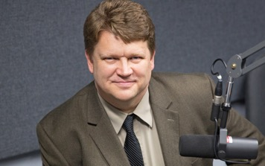

Thursday – 29
Please pray for Nadezhda and Katerina, FEBC’s workers in the Russian Far East. Pray for wisdom and continuous blessings on these sisters. Pray that God will use them mightily.

Friday – 30
Please pray for Yullia, an FEBC listener, who uses FEBC broadcasts to share the Gospel with her friends and co-workers in the post-war region of Ukraine.

Saturday – 31
Please pray for FEBC-Ukraine’s leadership team: Eduard, Maxim, Sergey, and Victor. Please pray for wisdom and the continuous empowerment of the Holy Spirit. Also pray for their families.

